Chapter 5 Electrical physics

Chapter test Total marks 45

Name: Class: Date: __________

Section A (1 mark per question)

Question 1

The lower vertical slot of any power point in your home will enable a connection to which of the following?

A the active part of the supply circuit

B the neutral part of the supply circuit

C the earth wiring in your home

D a fuse

Question 2

Which of the following factors affect the resistance of a conductor?

A length, lustre and temperature

B temperature, density and length

C length, area of cross-section and lustre

D area of cross-section, length and temperature

Question 3

Which of the following is the correct definition for electric current?

A the charge per unit volume per unit time

B the charge per unit volume

C the charge per unit time

D the time per unit charge

Question 4

How does the effective resistance of two identical resistors in parallel (*R*T) compare to the resistance of each individual resistor (*R*)?

A *R*T = *R*

B *R*T < *R*

C *R*T > *R*

D It depends on the resistance, *R*.

Question 5

How much current is drawn by a 6.0 W torch globe that uses two 1.5 V batteries placed in series?

A 0.5 A

B 4.0 A

C 9.0 A

D 2.0 A

Section B

Question 6

A negative charge lies within a uniform electric field of strength 5.00 × 10­4 N C­1 directed up the page. The charge on an electron is −1.60 × 10–19 C.

**a** Calculate the size of the force acting on the particle. (3 marks)

**b** Describe the effect of the force on the particle. (2 marks)

Question 7

Describe the energy transformations that occur during the operation of the circuit shown below when the switch is closed. (3 marks)

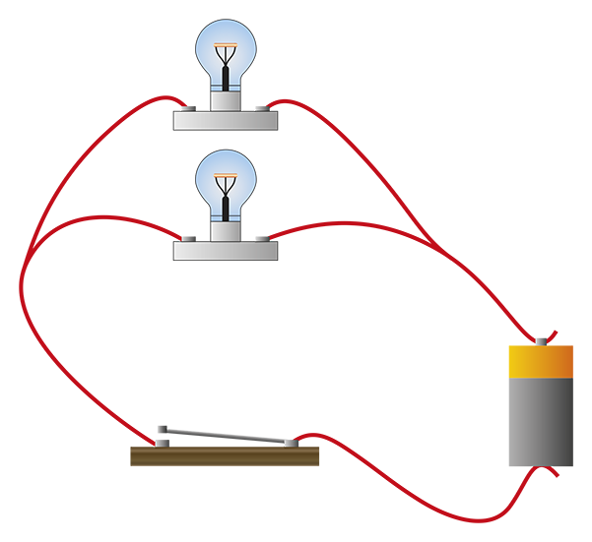

Question 8

**a** Samantha discovers that the 12.0 V battery in her new car is connected via a switch to   
two heater elements (resistors) in parallel, which are used to heat the driver and   
passenger seats. Draw a labelled diagram to represent this circuit. (3 marks)

**b** Thinking that the seats are not heating properly Samantha decides to use a voltmeter to   
check the operation of the switch. Draw how she would attach the voltmeter to the   
circuit in part a. (2 marks)

**c** When the switch is open, what value should the voltmeter read? (1 mark)

d When the switch is closed, what value should the voltmeter read? (1 mark)

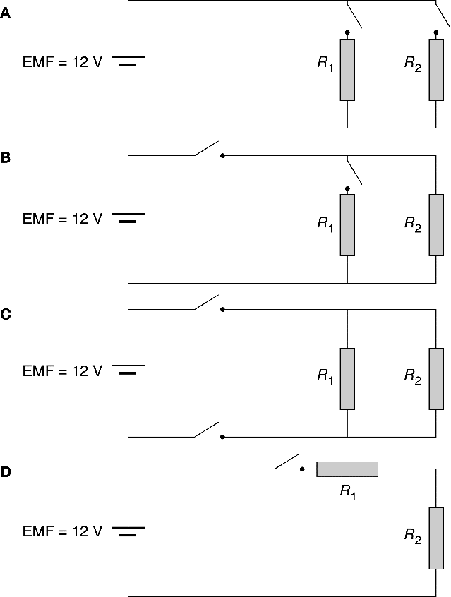**e** Samantha takes her car to an auto electrician who rewires the seat heating circuit to allow each seat to be individually heated. Which circuit diagram shows this? (1 mark)

**f** The resistors are identical and are rated at 300 Ω. What is the total resistance of the   
circuit when both seats are heated at the same time? (2 marks)

**g** What current is drawn when both seats are heated at the same time? (1 mark)

**h** If this amount of current were to go through a person it would cause serious injury.   
Does this mean that the seat warmer elements are potentially dangerous? (1 mark)

Question 9

A battery in a circuit has current of 4.50 A passing through it.

**a** How many coulombs of charge pass through the battery in 5.00 s? (1 mark)

**b** If the battery provides a potential difference of 9.00 V, how many joules of energy does it provide to the circuit each second? (2 marks)

Question 10

**a** How much energy, in kilowatt hours and joules, will a 200 W globe use in 4.00 hours of operation? (2 marks)

**b** An electricity company charges 60.0 cents per kW h of electricity consumed. How much does it cost to use this 200 W globe for one hour? (2 marks)

Question 11

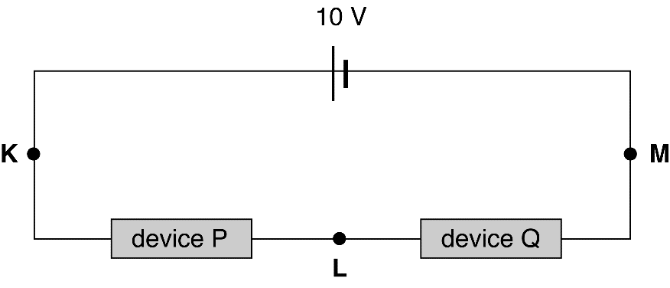Two electrical devices are connected in a series circuit as shown in the following diagram. The battery has zero internal resistance and the current at point K is 100 mA.

**a** What is the current at point L? (2 marks)

The current–voltage characteristics for these two devices are shown in the graphs below.

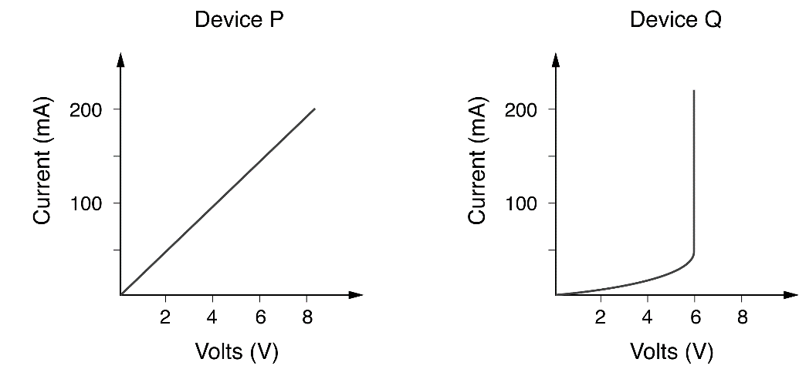

**b** Calculate the potential difference between points K and L. (2 marks)

**c** Calculate the potential difference between points L and M. (2 marks)

**d** What is the effective resistance of device Q in this situation? (2 marks)

**e** Which of these two components obeys Ohm’s law? (1 mark)

**f** Determine the resistance of the device you identified as ohmic in part a. (2 marks)

**g** What is the effective resistance of the other device when a current of 200 mA flows   
through it? Why is this not a useful quantity? (2 marks)